

Project Report

On

INTERIOR DESIGNER PORTFOLIO WEBSITE

Submitted by

Taranjeet Singh
Reg. No.: - 11713364

GitHub link-
https://github.com/tarandhod/Interior-designer-porfolio.git

Submitted to

Miss Neha Sharma
Assistant Professor
School of Computer Science & Engineering
Lovely Professional University

Landing Page:- As is a Interior Designer’s Portfolio, so on the landing page some overview of the work is shown along with nav bar on the top and basic details in the footer. Some reviews are also provided by previous clients. The website is created using react.js Here are the screen shots: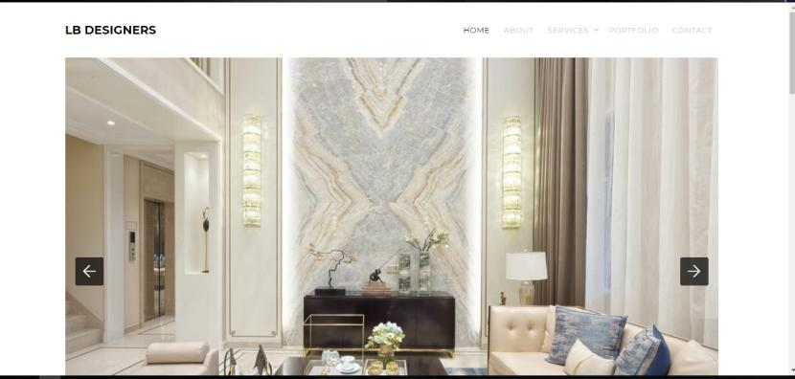 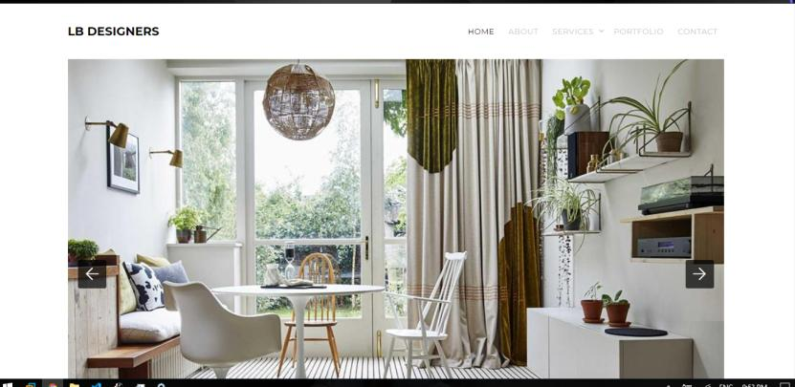
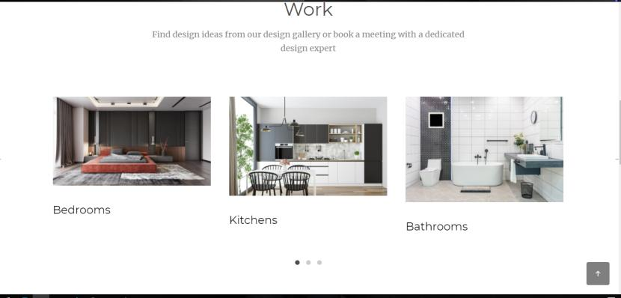
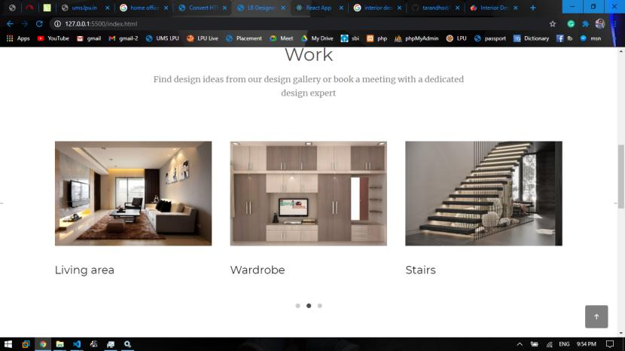
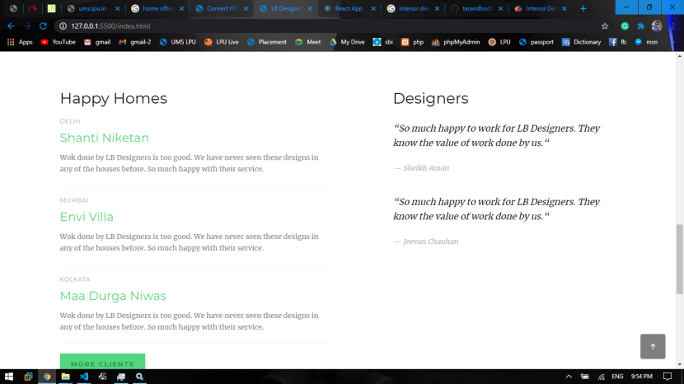
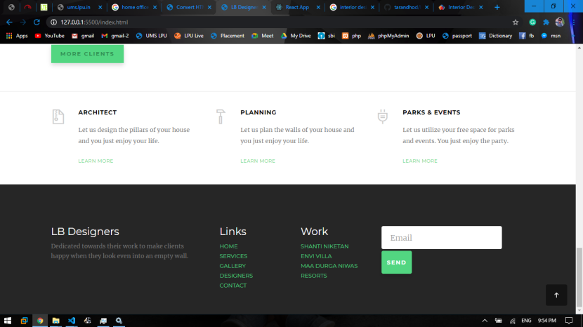
About Page: Then the about page is also provided where the designer can display all the information he/she want to show


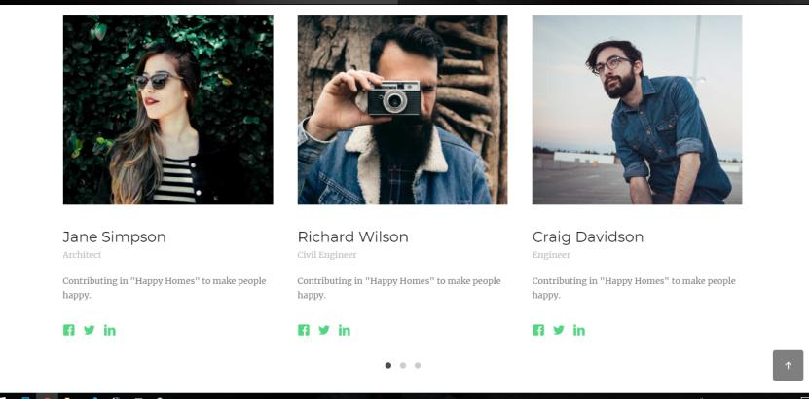
Services Page
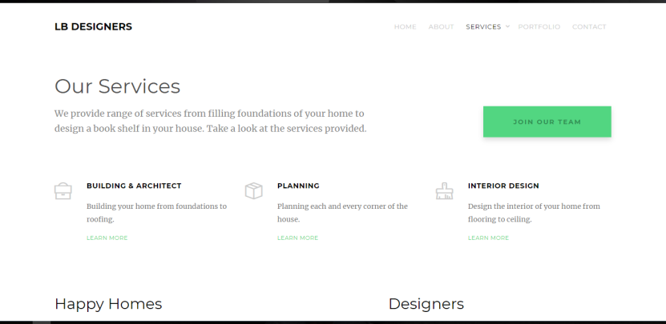

Contact us:
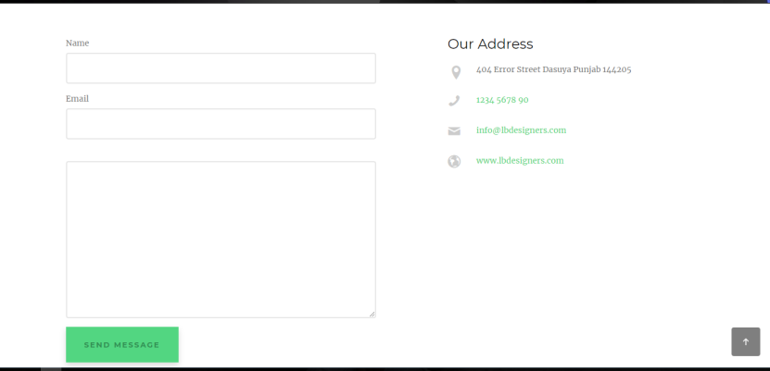
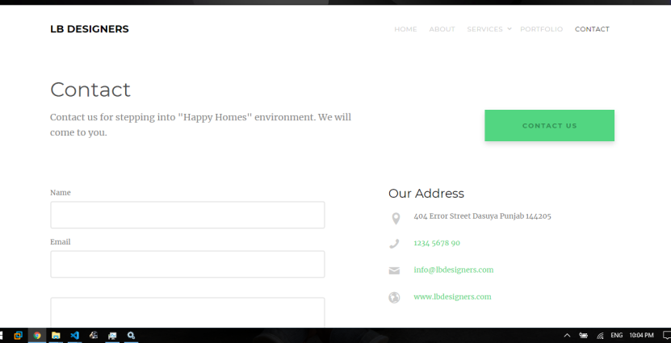
And over the Portfolio Page the Image gallery is displayed where the users can search among the different designs provided by the designer.
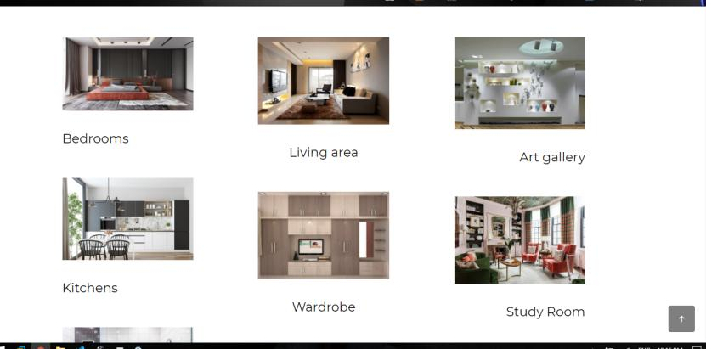
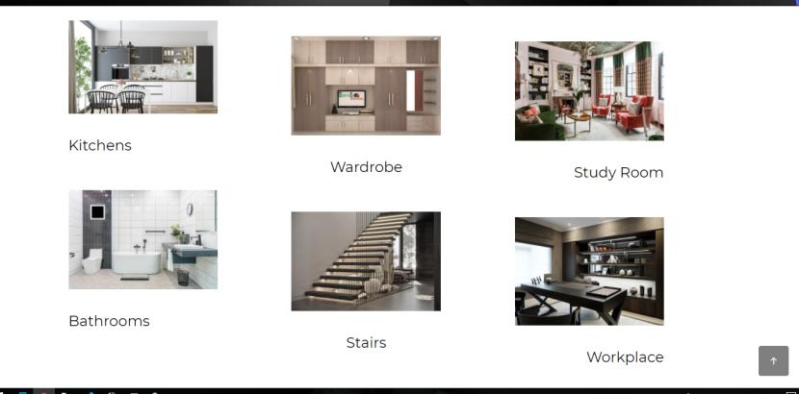
Code Snippets:
